PSYC 102
Portfolio Assignment5 - Chapter 11 &12
Deadline of submission (D2L dropbox online): 2016 March 14, Monday, midnight
PLEASE NOTE THAT ASSESSMENT OF THE ASSIGNMENT IS BASED ON THE FOLLOWING CRITERIA: (1) ACCURACY OF THE ANSWER, (2) CLARITY (3) ORIGINALITY AND (4) CONCISENESS
ALSO NOTE THAT 0.25 POINT DEDUCTION APPLIES FOR EXCEEDING THE WORD LIMIT (150) AS WELL AS FOR ANY VERBATIM QOUTATION FROM EXTERNAL SOURCES (INCLUDING THE TEXTBOOK).
The document must be submitted in a Microsoft Word format.
Name (fill in):
This assignment contains 3 questions (1 point each item)
- You are pretty much interested in figuring out more about your own personality. Therefore, you engage in a search and find a web site indicating that three theorists have significantly shaped our current understanding of personality. One is Sigmund Freud, whose ideas laid the foundation of a very influential personality theory based on the notion of inherited temperament. The second is B.F. Skinner, who was a Behaviorist, and approached personality from a different angle focusing on acquired response tendencies. The third is Carl Rogers, who strongly endorsed both of these theories but proposed a third one on his own integrating fundamental elements of both Freud and Skinner. How accurate do you think this information is? You need to provide a brief analysis focusing on the validity of the statement on each of the three theorists before coming to a conclusion. (150 words)

- Your friend argues that each nation has its own cultural character. She brings you data suggesting that the estimated prototype of “Canadian character” looks pretty similar to the one measured by researchers using a highly accurate and popular personality test. You look at the illustration (see below) and – based on what you have learned in your psychology classes – immediately assess the validity of the proof. Do you think the evidence supports your friend’s claim? Whether your answer is yes or no, you need to provide an intelligent and informed argument based on the analysis of the table below along with information found on the topic in the textbook (150 words) 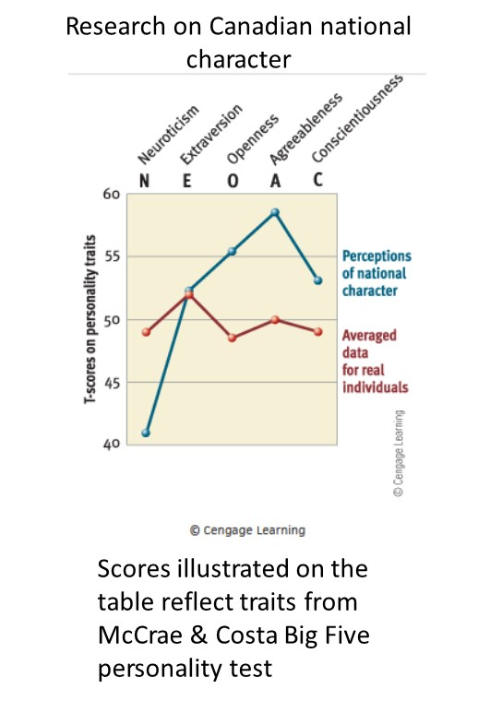

- You have an argument with one of your classmates in psychology who says that people are typically reasonable and would never engage in activities that are against their own moral principle. Based on what you have learned on social psychology, do you agree with your friend? Can you bring up one particular evidence which supports (or refutes) your friend’s statement? You need to provide an intelligent and informed argument based on scientific proof not just hunch. (150 words)

